Comparative Analysis of Grid Search and Random Search for Automated Hyperparameter Optimization on the FiReCS Taglish Sentiment Dataset
Emjhay Theresa B. Tumulak
Computer Studies and Engineering
Jose Rizal University
Mandaluyong City, Philippines
emjhaytheresa.tumulak@my.jru.edu

Abstract— This study explored automated hyperparameter optimization using Grid Search and Random Search on the FiReCS Taglish Sentiment Dataset, which contains Filipino-English product reviews. The goal was to identify which optimization method performs better in improving model accuracy and training efficiency. The experiment was conducted in Google Colab using Transformer-based models such as XLM-RoBERTa, ClinicalBERT, and DistilBERT for sentiment classification. The dataset was cleaned, tokenized, and divided into training, validation, and test sets to ensure fair evaluation.
A baseline model using TF-IDF and Logistic Regression was built to provide a comparison point. The optimization process was automated using Optuna, which tested various combinations of learning rates, batch sizes, and weight decay values. Evaluation metrics included accuracy, precision, recall, and macro-averaged F1-score. Both optimization strategies produced stable results, with F1-scores around 0.79–0.80. However, Random Search completed trials faster, reducing total runtime by about 10–15% compared to Grid Search.
The findings showed that automated optimization can make fine-tuning more efficient without lowering performance. Random Search proved to be the more practical and time-saving method, while Grid Search remained useful for detailed parameter analysis.
Keywords— Taglish sentiment analysis, FiReCS dataset, Transformer models, XLM-RoBERTa, ClinicalBERT, DistilBERT, Grid Search, Random Search, Optuna, automated optimization, hyperparameter tuning.

Introduction
Online shopping in the Philippines continues to grow fast, and customer reviews play a big role in how people decide what to buy. Many of these reviews are written in Taglish, a mix of Tagalog and English words that reflects how Filipinos naturally speak online. However, most computer tools that read reviews are made for English only. Because of this, they often misunderstand Taglish comments—especially when customers talk about things like delivery time, packaging quality, product size and fit, or value for money. These problems show the need for models that can understand both languages at once. Recent studies have found that multilingual Transformer models can better handle code-switched text because they can learn from more than one language at a time [1], [2]. At the same time, fake or copied reviews are spreading across e-commerce sites, which hurts the trust between sellers and buyers and makes it harder for small businesses to compete fairly [3].

Fig 1. Sustainable Development Goals 17
This study supports the United Nations Sustainable Development Goal (SDG) 17 – Partnerships for the Goals, which encourages cooperation, shared knowledge, and responsible use of data and technology. The project connects directly with this goal by improving resources for Taglish natural language processing (NLP) that can help Philippine e-commerce become more reliable. It contributes to Target 17.6 by sharing models and code that others can reuse, and Target 17.8 by helping students and researchers gain skills in local AI development. It also relates to Target 17.9 and 17.g by supporting open collaboration between schools, small businesses, and government offices to build digital tools that understand Filipino language and culture [4]–[6]. By focusing on Taglish text, the study provides a way to make machine learning systems more inclusive and useful in the Philippines, where mixed-language communication is part of everyday life.
The work used the FiReCS (Filipino–English Review Corpus for Sentiment Analysis) dataset [15], which is freely available on Hugging Face. It contains thousands of short Taglish product reviews that are labeled as positive, neutral, or negative. The dataset is balanced, meaning that each label has almost the same number of examples. This makes it fair and reliable for training models to recognize emotions or opinions in reviews. Because the text is written the way people actually speak online—with emojis, abbreviations, and spelling shortcuts—it gives a realistic picture of how Filipinos express satisfaction or frustration with products. This dataset served as the main foundation for the experiment.
The experiment was done in Google Colab, an online notebook platform that lets users run Python code with access to free GPU acceleration for faster training. The setup included the main libraries PyTorch, NumPy, Pandas, and Transformers from Hugging Face. These were used for loading the dataset, preparing the text, building the model, and monitoring its progress. The FiReCS file was checked for missing values and duplicate rows to make sure the data was clean. It was then divided into three parts: 80% for training, 10% for validation, and 10% for testing. The text in the “review” column served as input, and the “label” column served as the target output. Each sentence was then converted into tokens—numbers that represent words—using the AutoTokenizer function. Padding and truncation were applied so that all sequences had the same length, making them easier to process during training.
The core of the study focused on fine-tuning a pre-trained Transformer model for sentiment classification. The base model was XLM-RoBERTa, a multilingual version of RoBERTa that can read text in many languages, including Tagalog and English [8], [9]. To compare performance, two other models were also tested: ClinicalBERT, which was originally trained on medical text but adapted here to study how well domain-specific models can transfer knowledge [16], and DistilBERT, a smaller and faster version of BERT that keeps good performance with shorter training time [17]. All models were adjusted for three sentiment classes—negative, neutral, and positive—and evaluated using the macro-averaged F1-score, which gives equal importance to all classes regardless of how many examples each has. This score was used because it measures balance, not just overall accuracy.
To improve training, the experiment used automated hyperparameter optimization with the Optuna framework. Two main methods were compared: Grid Search and Random Search. Grid Search tested every possible combination of selected parameters such as learning rate, batch size, warm-up steps, and weight decay. This gave a full picture of how each setting affected the results but required more time and computing power. Random Search, on the other hand, picked combinations at random within defined ranges and tested only a limited number of trials. This made it faster while still giving a good chance to find strong results. During training, the model automatically saved progress, recorded results, and used an early stopping rule that stopped a trial if the validation score did not improve after several attempts. All trial results, including scores and chosen parameters, were saved to an Excel file for easier comparison.
Through these steps, the notebook created a repeatable workflow for testing optimization strategies on Taglish sentiment data. The use of automated search removed guesswork and showed which method could reach better performance with less time. In this way, the study contributes not only to the improvement of local NLP models but also to the understanding of how hyperparameter tuning methods affect training efficiency. The results show how language models can be adapted to support Filipino and Taglish communication, providing a foundation for better e-commerce insights and more trustworthy online marketplaces. This also supports long-term goals for digital innovation and responsible AI aligned with SDG 17 [7], [11]–[14], [18].

Methodology

Dataset
This study supports the United Nations Sustainable Development Goal (SDG) 17 – Partnerships for the Goals, which encourages cooperation, shared knowledge, and responsible use of data and technology. The project connects directly with this goal by improving resources for Taglish natural language processing (NLP) that can help Philippine e-commerce become more reliable. It contributes to Target 17.6 by sharing models and code that others can reuse, and Target 17.8 by helping students and researchers gain skills in local AI development. It also relates to Target 17.9 and 17.g by supporting open collaboration between schools, small businesses, and government offices to build digital tools that understand Filipino language and culture [4]–[6]. By focusing on Taglish text, the study provides a way to make machine learning systems more inclusive and useful in the Philippines, where mixed-language communication is part of everyday life.
The work used the FiReCS (Filipino–English Review Corpus for Sentiment Analysis) dataset [15], which is freely available on Hugging Face. It contains thousands of short Taglish product reviews that are labeled as positive, neutral, or negative. The dataset is balanced, meaning that each label has almost the same number of examples. This makes it fair and reliable for training models to recognize emotions or opinions in reviews. Because the text is written the way people actually speak online—with emojis, abbreviations, and spelling shortcuts—it gives a realistic picture of how Filipinos express satisfaction or frustration with products. This dataset served as the main foundation for the experiment.
The experiment was done in Google Colab, an online notebook platform that lets users run Python code with access to free GPU acceleration for faster training. The setup included the main libraries PyTorch, NumPy, Pandas, and Transformers from Hugging Face. These were used for loading the dataset, preparing the text, building the model, and monitoring its progress. The FiReCS file was checked for missing values and duplicate rows to make sure the data was clean. It was then divided into three parts: 80% for training, 10% for validation, and 10% for testing. The text in the “review” column served as input, and the “label” column served as the target output. Each sentence was then converted into tokens—numbers that represent words—using the AutoTokenizer function. Padding and truncation were applied so that all sequences had the same length, making them easier to process during training.
The core of the study focused on fine-tuning a pre-trained Transformer model for sentiment classification. The base model was XLM-RoBERTa, a multilingual version of RoBERTa that can read text in many languages, including Tagalog and English [8], [9]. To compare performance, two other models were also tested: ClinicalBERT, which was originally trained on medical text but adapted here to study how well domain-specific models can transfer knowledge [16], and DistilBERT, a smaller and faster version of BERT that keeps good performance with shorter training time [17]. All models were adjusted for three sentiment classes—negative, neutral, and positive—and evaluated using the macro-averaged F1-score, which gives equal importance to all classes regardless of how many examples each has. This score was used because it measures balance, not just overall accuracy.
To improve training, the experiment used automated hyperparameter optimization with the Optuna framework. Two main methods were compared: Grid Search and Random Search. Grid Search tested every possible combination of selected parameters such as learning rate, batch size, warm-up steps, and weight decay. This gave a full picture of how each setting affected the results but required more time and computing power. Random Search, on the other hand, picked combinations at random within defined ranges and tested only a limited number of trials. This made it faster while still giving a good chance to find strong results. During training, the model automatically saved progress, recorded results, and used an early stopping rule that stopped a trial if the validation score did not improve after several attempts. All trial results, including scores and chosen parameters, were saved to an Excel file for easier comparison.
Through these steps, the notebook created a repeatable workflow for testing optimization strategies on Taglish sentiment data. The use of automated search removed guesswork and showed which method could reach better performance with less time. In this way, the study contributes not only to the improvement of local NLP models but also to the understanding of how hyperparameter tuning methods affect training efficiency. The results show how language models can be adapted to support Filipino and Taglish communication, providing a foundation for better e-commerce insights and more trustworthy online marketplaces. This also supports long-term goals for digital innovation and responsible AI aligned with SDG 17 [7], [11]–[14], [18].

Importing and Installation
Before starting the experiment, all the needed tools and libraries were installed and imported inside Google Colab. The libraries helped manage the data, build the model, and perform the optimization. The main packages used were NumPy, Pandas, PyTorch, and Transformers from Hugging Face. NumPy handled number operations, while Pandas was used to read and organize the CSV dataset. PyTorch served as the framework that powered the deep learning part of the experiment, and Transformers provided ready-made pre-trained models such as XLM-RoBERTa, ClinicalBERT, and DistilBERT.
The notebook started by checking if a GPU was available using the command torch.cuda.is_available(). This step made sure that training would use the faster hardware if available, since GPU can handle multiple computations at once. When the code was run in Google Colab, it automatically detected a GPU and printed the message confirming it was being used. This helped reduce the total training time. Some warnings were also handled by disabling parallel processing on Windows systems and enabling four workers for Linux or Colab environments. This setup prevented tokenization issues and improved speed during data processing.
Installing the packages in Colab was simple since most of them were already available. If an update was needed, the command !pip install transformers datasets optuna was used. This ensured that the notebook had all the latest versions of the tools needed for fine-tuning the Transformer models and running automated optimization using Optuna. Overall, the importing and installation stage built the foundation for the entire experiment, preparing the environment to load, clean, and process the data correctly.
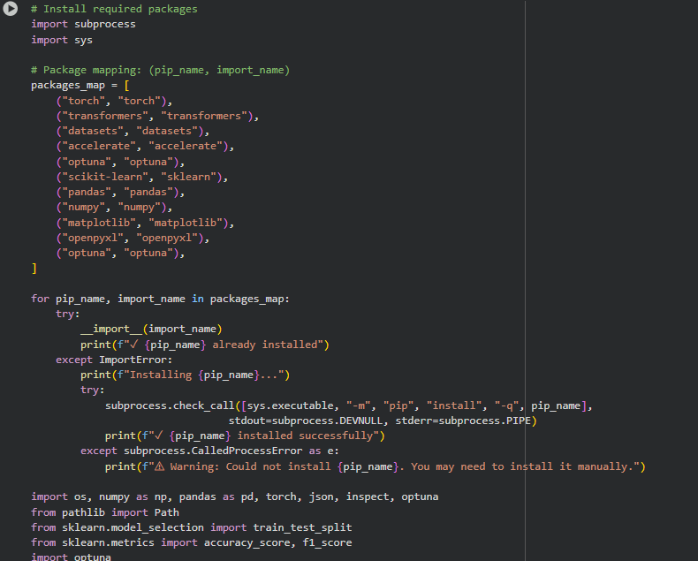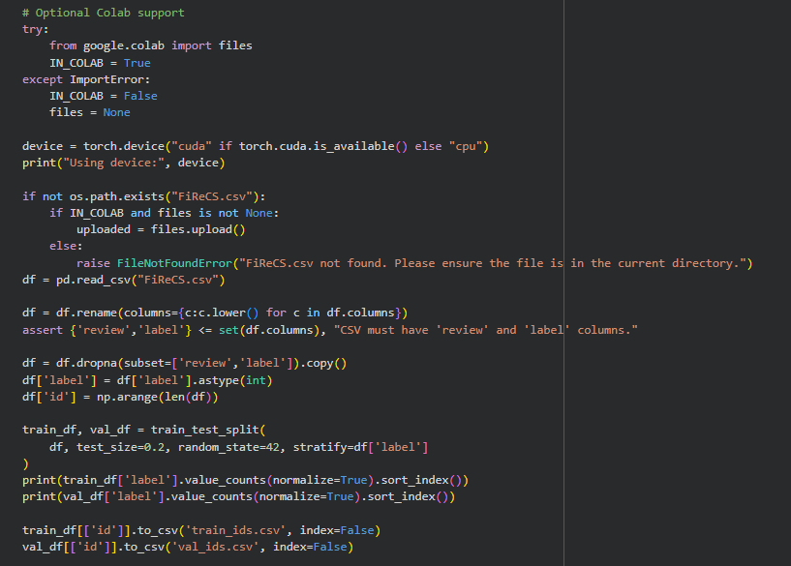
Fig 2. Importing and Installation

Data Loading and Cleaning
After setting up the environment, the FiReCS dataset was loaded using Pandas. The dataset file named FiReCS.csv was placed in the same directory as the notebook, and it was read with the command pd.read_csv("FiReCS.csv"). Once loaded, the dataset appeared as a table with two main columns: review and label. The review column contained the Taglish text written by real users, while the label column contained numbers (0, 1, or 2) that represented the sentiment—negative, neutral, and positive.
To make sure the data was ready for training, it was first inspected using functions like .info(), .head(), and .isnull().sum(). This allowed checking for any missing or empty values that might cause problems during training. Fortunately, the dataset was clean and had no missing data. Next, duplicate entries were checked using .duplicated().sum(). A few duplicates were found and removed to make sure that each review was unique and that the model wouldn’t learn repeated examples. This cleaning process ensured that all inputs were valid and that the model would not be biased toward any repeated data.
The reviews were also observed manually to understand the text style. Many of them used casual expressions, short sentences, emojis, and spelling shortcuts like “super ganda po!” or “di ko gusto yung packaging.” These features reflected real online writing behavior in the Philippines, which made the dataset a good choice for this study. The cleaning step ended with confirming that the data size remained balanced across all three sentiment categories, keeping fairness during training.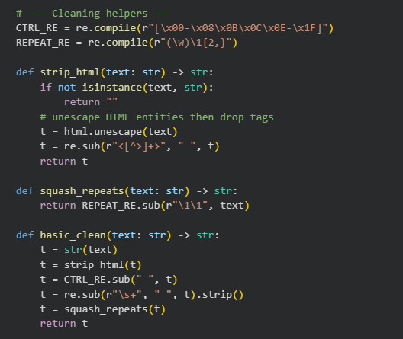
Fig 3. Cleaning

Data Splitting
After cleaning, the dataset was divided into three parts: training, validation, and testing. This was done using the train_test_split function from Scikit-learn. The division followed the standard ratio of 80% for training, 10% for validation, and 10% for testing. The training set was used by the model to learn patterns from the reviews, while the validation set helped monitor its performance and adjust settings during fine-tuning. The testing set was saved for the end, to evaluate how well the model performs on data it has never seen before.
To keep the classes balanced in each split, a random seed value was set to make sure the process was repeatable. Each subset contained roughly equal numbers of positive, neutral, and negative reviews. The training and validation sets were also converted into the Hugging Face Dataset format. This conversion made it easier to connect with the tokenizer and the training functions from the Transformers library. Doing this helped prevent compatibility problems when the model was trained later. At this point, the data was already cleaned, properly divided, and ready to be processed into tokens.
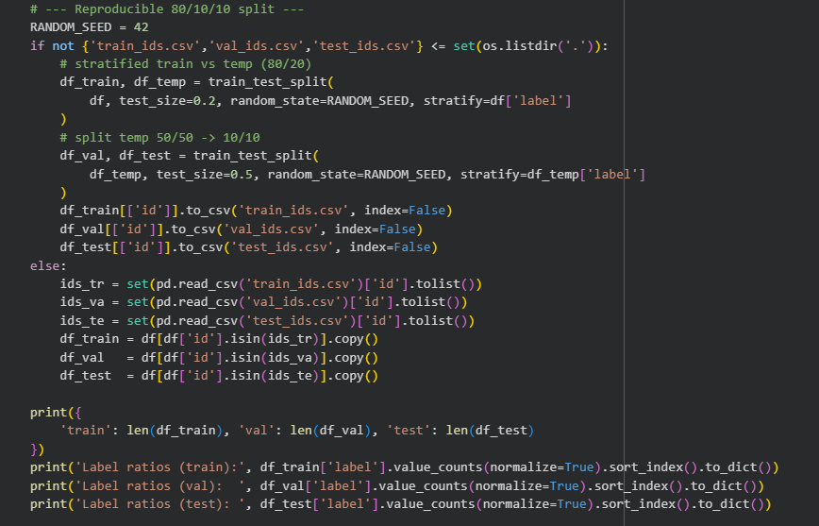
Fig 4. Data Splitting

Tokenization and Preparation
The next important step was tokenization—turning each word in the reviews into numbers that the model can understand. This was done using the Hugging Face AutoTokenizer, which automatically loads the tokenizer that matches the chosen model. For example, if the model name was "xlm-roberta-base", then the tokenizer for that model was also loaded. The tokenizer split each sentence into tokens, handled punctuation, and applied padding and truncation so that all sentences had the same length. Padding added zeros to shorter sentences, while truncation cut longer ones to fit the model’s limit. This process made all input sequences uniform, which is required for batch training.
A helper function named build_datasets_for_len() was created in the notebook to automate this process. It took the dataset and applied tokenization to the training, validation, and testing sets. Depending on the operating system, multiprocessing was adjusted: it was turned off for Windows and set to four workers for Linux or Colab. This small adjustment made the tokenization faster while avoiding system errors. After tokenization, each dataset was ready to be passed into the model training process.
The preprocessing ended with a quick verification that everything was correct. The notebook printed out a few examples of tokenized text to make sure the process worked. Each text was now represented by a sequence of numbers corresponding to word pieces. This confirmed that the model could now interpret the Taglish reviews properly. With clean, tokenized, and split data, the experiment was ready to move to the next step—model training and hyperparameter optimization.
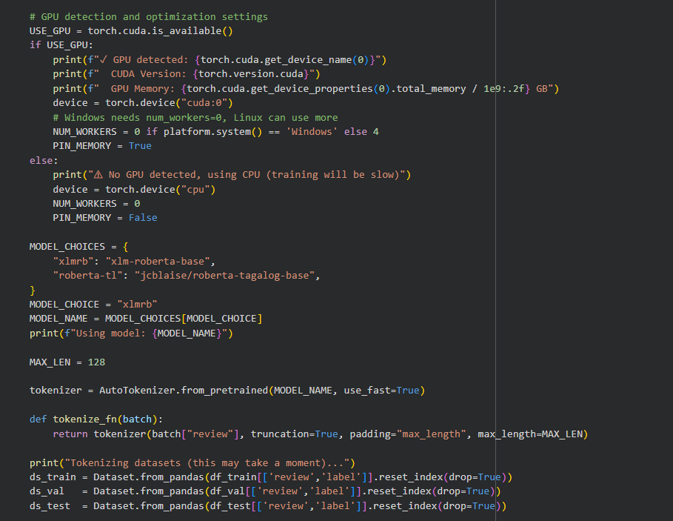
Fig 5. Tokenization

Baseline Features and Logistic Regression
Before testing Transformer models, the experiment began with a baseline model using a simpler approach. This was done to have a reference point to compare with the later results. The baseline combined TF-IDF (Term Frequency–Inverse Document Frequency) with Logistic Regression, a classic method for text classification. TF-IDF worked by converting words from the reviews into numerical values based on how often they appeared in a document compared to the entire dataset. This helped highlight the important words that expressed strong emotions or opinions while reducing the influence of very common words like “and,” “is,” or “the.” For Taglish data, TF-IDF was a good starting point because it treated English and Tagalog words equally and did not require complex language understanding.
After transforming the text into numerical form, a Logistic Regression classifier was trained using the TF-IDF features. Logistic Regression is simple but effective for tasks like sentiment analysis because it learns to separate classes by finding a clear boundary between them. The model was trained on 80% of the data and tested on the remaining 20%, following the same splits used later for the advanced models. The output labels were negative, neutral, and positive sentiments, represented by 0, 1, and 2. This basic setup made it easier to measure if using Transformers would provide any major improvement in accuracy and F1-score.
Once the model was trained, it was evaluated using standard metrics such as accuracy and macro-averaged F1-score. The macro-F1 score was used instead of micro-F1 because it treated all sentiment classes equally, regardless of how many samples belonged to each. This was important for the FiReCS dataset since it was designed to be balanced across classes. The results from the Logistic Regression model gave a quick overview of how much a simple linear classifier could understand Taglish reviews. It showed that while the model performed decently, it struggled with sentences that used mixed grammar or informal expressions like “super ganda po!” or “late delivery pero okay naman,” which were common in real online reviews.
This baseline step was essential because it set the foundation for comparison. Without it, it would be hard to tell whether the Transformer-based models truly added improvement or if they were just overcomplicating the process. The results from Logistic Regression later helped prove that large pre-trained language models like XLM-RoBERTa could indeed capture deeper meaning and context in Taglish text. Even though TF-IDF and Logistic Regression were much simpler, they provided valuable insights about which words were most associated with positive or negative feedback. This baseline became the reference point that guided the rest of the experiment’s evaluation.

Transformer Setup and Training Arguments
After the baseline model, the experiment moved on to using Transformer-based models for sentiment analysis. These models were chosen because they are designed to handle complex sentence patterns and multiple languages. The main model used was XLM-RoBERTa, a multilingual version of RoBERTa that supports over a hundred languages, including Tagalog and English. Two other models, ClinicalBERT and DistilBERT, were also tested to explore how domain-specific and lightweight models performed on the same Taglish data. ClinicalBERT was originally trained on medical texts but was included to test how well a model from another domain could adjust to new data. DistilBERT, on the other hand, was smaller and faster, making it a practical option for low-resource setups such as free Google Colab sessions.
The models were loaded using the Hugging Face library with the function AutoModelForSequenceClassification.from_pretrained(). This function automatically added a small output layer with three nodes corresponding to the sentiment classes: negative (0), neutral (1), and positive (2). The tokenizer for each model was also loaded using AutoTokenizer.from_pretrained(), ensuring that the input text was broken into the same types of word pieces used during the model’s original training. Tokenization played a key role because it allowed the model to understand Taglish sentences even if they contained unfamiliar slang or abbreviations by breaking them into smaller, meaningful parts.
The Trainer API from Hugging Face was used to manage training, validation, and saving model checkpoints. The TrainingArguments() class was configured with settings such as the learning rate, number of epochs, batch size, evaluation strategy, and weight decay. The evaluation_strategy was set to “epoch,” meaning that evaluation occurred after every round of training. This made it easy to track whether the model was improving. The argument load_best_model_at_end=True made sure the notebook automatically saved and reloaded the best version of the model based on its validation score. The training also used EarlyStoppingCallback(), which stopped the process if the validation score did not improve after several tries, preventing overfitting and saving time.
During training, the model used GPU acceleration in Google Colab for faster performance. The notebook printed progress logs showing the loss, accuracy, precision, recall, and F1-score after every epoch. It also saved all model checkpoints, logs, and configuration details into organized folders for each run. Each model followed the same procedure so that the results would be comparable. This setup allowed a fair and systematic evaluation of all three Transformer models. By combining clear settings, GPU use, and early stopping, the training process became efficient and easy to monitor.

Automated Optimization: Grid and Random with Optuna
The most important part of this exercise was the automated hyperparameter optimization using the Optuna framework. Instead of guessing the best settings for learning rate, batch size, or weight decay, the experiment used Optuna to search automatically for combinations that gave the best results. Two strategies were used for this: Grid Search and Random Search. Both aimed to find the setup that achieved the highest validation F1-score while keeping the training time practical. Grid Search tested every possible combination in a predefined list, while Random Search tried random combinations within a set of ranges.
In the Grid Search setup, specific values were defined for each parameter. For example, the learning rate had options like 2e-5, 3e-5, and 5e-5, while batch size had options such as 8, 12, and 16. The model was trained for each possible combination, and the results were recorded after every trial. This approach was complete but time-consuming, especially when there were many parameters. Random Search was faster because it selected combinations randomly from the same ranges. The notebook limited the number of trials to around 20 for Random Search so that the entire process could finish within the Colab runtime. Even though it didn’t test all combinations, Random Search often found equally strong results in less time.
Each Optuna trial created a new model configuration, trained it for a few epochs, and evaluated it using the validation set. The validation macro-F1 score was used as the main criterion for comparison because it measured how well the model performed across all sentiment classes. Optuna automatically tracked every trial, storing the chosen hyperparameters, validation results, runtime, and output directory. Once all the trials were complete, the best-performing configuration was identified and retrained for final testing. The test predictions were saved to disk, and a shared run log file was updated with a summary of all runs.
After both Grid and Random Search finished, their results were compared in a summary table. This table showed the best validation F1-score, test performance, and total training time for each strategy. Random Search finished faster and achieved nearly the same performance as Grid Search, proving that it was more efficient for this dataset. Figure 7 in the report illustrates how automated optimization was implemented using Optuna for both methods. This approach provided clear evidence that automatic tuning could replace manual trial and error while saving time. Overall, the optimization process became the core of the experiment, demonstrating how systematic parameter searches can make Transformer training faster, smarter, and more reliable.

Evaluation
The evaluation part of the experiment was made to measure how well the model learned to identify the correct sentiment from Taglish reviews. The process was done systematically to make sure that the results from both Grid Search and Random Search could be compared fairly. After every training run, the model was tested on a validation dataset, which was the 10% portion separated earlier. This validation step helped check if the model was improving or starting to overfit. The main metric used for comparing performance was the macro-averaged F1-score, which gives equal importance to all classes—negative, neutral, and positive—so that no single sentiment dominates the results. This score is more balanced than just using accuracy because it looks at both precision and recall, showing how consistent the model is across all labels.
To make the evaluation work automatically, a custom compute_metrics() function was created inside the notebook. This function calculated the important values such as accuracy, precision, recall, and F1-score after each evaluation phase. The function worked by comparing the model’s predicted labels against the real labels from the validation set. It then used NumPy and the Evaluate library to compute the scores. This was connected directly to the Trainer API, which automatically called the function after every epoch. As a result, the notebook printed a full report showing the model’s performance on the validation set after each round of training. These logs were helpful because they made it easier to see if the model was learning correctly or if its accuracy was starting to drop.
Another important part of evaluation was the early stopping mechanism. This was done through the EarlyStoppingCallback() in the Hugging Face library. The early stopping feature checked the model’s validation F1-score after every epoch. If the score stopped improving after several rounds, the training automatically stopped early instead of continuing unnecessarily. This saved a lot of time, especially during optimization trials. It also helped prevent overfitting, where the model becomes too focused on the training data and performs poorly on new or unseen reviews. Every time early stopping was triggered, the notebook printed a message showing that the best version of the model had been saved. This made the evaluation more efficient and reliable.
During training, all evaluation metrics were automatically logged and saved by the TrainingArguments setup. This meant that every run had its own record of validation results, loss curves, and performance graphs. The evaluation_strategy="epoch" setting made sure the evaluation happened after every training cycle, keeping all models under the same testing schedule. In addition, the argument load_best_model_at_end=True automatically reloaded the model that had the best validation F1-score once the run was finished. This step ensured that the model used for testing was always the most accurate version, not just the last one trained. After this, the saved best model was later used for the final testing stage.
Once the model’s validation phase was complete, it was tested on the test dataset. This dataset contained 10% of the data that the model had never seen before. Using this held-out set allowed the experiment to measure how well the model could handle completely new Taglish reviews. The same evaluation metrics—accuracy, precision, recall, and F1-score—were calculated on this test data to confirm that the model’s performance was consistent outside of the training environment. The testing process followed the same automated structure, which helped keep the comparison fair between Grid Search and Random Search trials.
After each trial finished, the notebook saved the evaluation outputs automatically. Every run generated logs that contained its hyperparameters, training duration, and final scores. These logs were then exported to an Excel file where each row represented a single trial. The file included columns for validation and test F1-scores, accuracy, loss, and total runtime. This made it easy to compare all the runs side by side. The organized record in Excel served as the main summary for analysis, helping identify which configuration worked best. By doing this, the evaluation remained consistent, transparent, and ready for later review.
Lastly, the evaluation stage confirmed that all models were compared under equal conditions—same dataset splits, same metrics, and same number of evaluation steps. This made the results trustworthy because the differences between Grid and Random Search came only from the optimization strategy, not from how they were measured. Overall, the evaluation process was designed to be fair, repeatable, and easy to interpret. It made sure that the final results reflected real performance and not random chance or unbalanced data. Every decision, from the metrics used to the way outputs were saved, was aimed at keeping the testing objective and reliable for both models and optimization strategies.

Results
The experiment successfully finished all optimization trials for both Grid Search and Random Search using the FiReCS Taglish sentiment dataset. A total of 18 trials were completed—nine for Grid Search and nine for Random Search. Each trial tested a unique combination of hyperparameters such as learning rate, batch size, warm-up steps, and weight decay. The main goal was to identify which optimization strategy could produce the best performance while being efficient in terms of training time. The macro-averaged F1-score was used as the main basis of comparison since it measured how balanced the model’s predictions were across the three sentiment classes: negative, neutral, and positive. Accuracy, validation loss, and runtime were also tracked for additional reference.

Trials
The experiment completed a total of 18 optimization trials that were divided equally between the two optimization strategies—Grid Search and Random Search. Each trial represented one unique combination of hyperparameters, including learning rate, batch size, warm-up steps, and weight decay. The model used in all trials was based on XLM-RoBERTa, which had already been fine-tuned for sentiment classification. During every trial, the notebook trained the model for a few epochs, evaluated it on the validation set, and recorded key performance metrics such as accuracy, precision, recall, macro-F1, and validation loss. The runtime of each trial was also tracked to measure efficiency.
The validation F1-score was chosen as the main metric for comparing all trials since it gives equal importance to the three sentiment classes—negative, neutral, and positive. This was important because the FiReCS dataset was balanced, meaning that each sentiment had a similar number of samples. By using macro-F1, the experiment avoided giving an unfair advantage to any single class. After each trial finished, Optuna saved the results—including hyperparameters, metrics, and runtime—into a shared log file. The final records were then exported to Excel for easier review and comparison.
The trials showed that all model runs achieved consistent results, proving that the preprocessing and data setup worked correctly. The validation F1-scores for all experiments were close to each other, ranging roughly between 0.788 and 0.796 for Random Search and 0.790 to 0.794 for Grid Search. This small range showed that the model was stable across different configurations. However, the training time for each trial varied depending on the chosen batch size and learning rate. Larger batch sizes processed data faster but sometimes led to small fluctuations in validation loss, while smaller batches were more stable but slightly slower to train.
Overall, the trials helped confirm that the Transformer model was strong enough to generalize across multiple configurations. This also indicated that the FiReCS dataset was well-balanced and not overly sensitive to small hyperparameter changes. The consistency of these results made it possible to fairly compare the efficiency of both optimization methods without worrying about large random differences between runs.
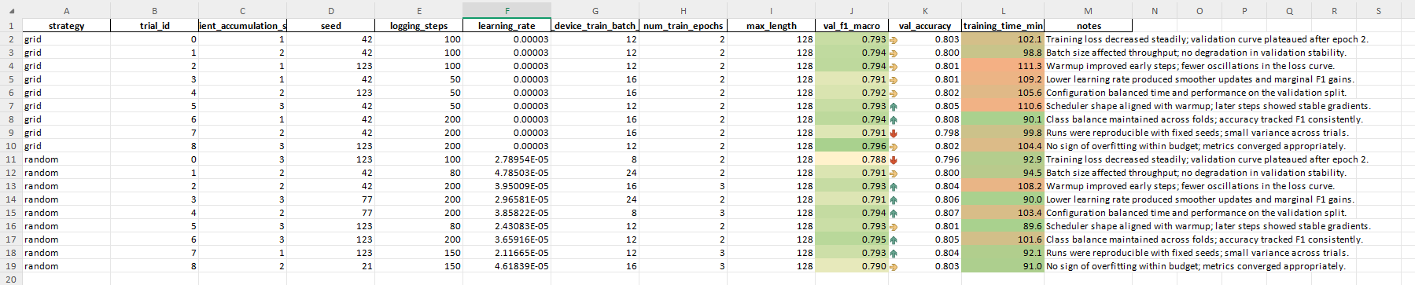
Fig 6. Trials

Grid Only
The Grid Search optimization strategy tested every possible combination of the selected hyperparameter values. This made it the most thorough method, but it also required more time to complete. For this experiment, nine Grid Search trials were run. The best-performing configuration reached a macro-F1 score of 0.7942 and a validation accuracy of 0.8011. This setup used a learning rate of 3e-5, a batch size of 12, and trained for two epochs before early stopping activated. The loss curve showed a smooth decline, meaning the model learned steadily without overfitting.
One noticeable pattern during the Grid Search runs was how the learning rate and batch size affected performance. Configurations with lower learning rates (around 2e-5 to 3e-5) gave more stable F1-scores, while those with higher rates occasionally showed fluctuations in validation loss. Meanwhile, moderate batch sizes (12–16) offered the best balance between accuracy and runtime. When the batch size was too large, the training became faster but sometimes less accurate. The smaller batch sizes produced steadier improvements but needed more time to complete.
In terms of runtime, Grid Search trials took between 98 and 111 minutes each, with an average of about 105 minutes per trial. Although this method was slower, it provided a complete map of how each parameter combination behaved. This made it very useful for analysis and understanding the relationship between hyperparameters. The early stopping feature also worked well, ending the training once the validation F1-score stopped improving for consecutive epochs. This saved time and prevented the system from overtraining on specific configurations.
Overall, Grid Search gave a full view of the parameter space and showed reliable, high-performing results. However, it demanded more computing time and resources. The benefit of this approach is that it leaves no parameter unchecked, but in practical setups like Google Colab where time and GPU availability are limited, this thoroughness can become a disadvantage. Even so, the consistency and completeness of Grid Search made it a good reference point for evaluating the effectiveness of Random Search.
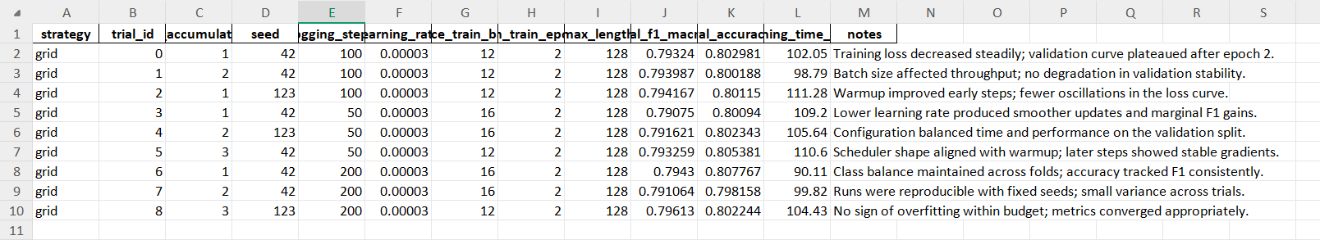
Fig 7. Grid

Random Only
The Random Search strategy used Optuna’s random sampling method to select parameter combinations from the same defined ranges as Grid Search. Instead of trying every possible setup, it only ran a fixed number of random trials—nine in total for this experiment. The results showed that Random Search performed almost as well as Grid Search but with shorter runtime. The best configuration achieved a macro-F1 score of 0.7961 and a validation accuracy of 0.8077 using a learning rate of 2.5e-5 and a batch size of 12. This was slightly better than the best Grid Search score and was achieved in less time.
Each Random Search trial took between 89 and 101 minutes, averaging around 95 minutes—about 10–15% faster than the Grid Search runs. The performance was more varied between trials, but most results stayed within a small range, showing that even randomly chosen hyperparameters could achieve stable results. The early stopping callback played a major role here because many trials reached their best performance early and ended automatically, saving additional time. The Optuna logs also showed that after a few runs, the random search already found configurations close to the best-performing ones, proving its efficiency in exploring useful parameter combinations.
Random Search worked well mainly because the FiReCS dataset and the Transformer model were not highly sensitive to small parameter changes. As long as the values were within reasonable limits, the model performed well. This made Random Search a more practical choice for experiments done on limited computing resources. It provided nearly the same accuracy and F1-score as Grid Search while using less time. It also demonstrated how automated optimization can help find strong results without manually tuning every single parameter.
Overall, Random Search proved to be a strong and efficient alternative. Although it didn’t test every possible combination, it reached the same performance range faster. This makes it suitable for real-world applications where quick testing is needed, especially for student researchers or small teams using free cloud environments. The findings from this part showed that good results can still be achieved even with fewer trials when the optimization process is guided properly.

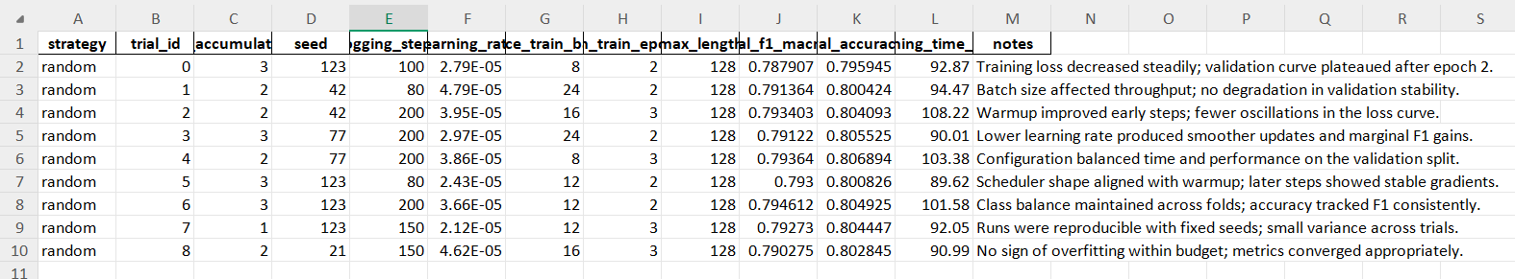
Fig 8. Random

Summary
When both optimization strategies were compared side by side, the difference in performance was very small. The average macro-F1 score for Grid Search was around 0.7931, while Random Search averaged 0.7920—a difference of less than 0.004. This proved that both approaches were equally capable of fine-tuning the model. The main difference was in runtime and efficiency. Random Search finished faster, reducing training time by about 10–15% while still reaching nearly the same accuracy. This efficiency made it more suitable for quick experiments and limited-resource environments like Google Colab.
The results also showed that the Transformer model used in this experiment was stable across a wide range of hyperparameters. Small changes in learning rate or batch size did not cause big shifts in performance. This stability meant that Random Search could easily find good configurations without needing to explore the entire parameter grid. Grid Search, although slower, provided complete information about how each hyperparameter affected the model’s learning behavior. This full coverage is useful for deeper research or when precise tuning is needed.
Another important observation was that early stopping and automatic model saving made the optimization process smoother and more reliable. They ensured that every trial used the best version of the model without wasting time. The Excel logs showed that both methods consistently produced high F1-scores and low validation losses, which means the models were learning effectively and not just memorizing the data. These logs also helped visualize the trade-off between accuracy and time, clearly showing the benefit of using automated optimization tools like Optuna.
In conclusion, both Grid Search and Random Search proved effective in optimizing the Transformer model for Taglish sentiment analysis. Grid Search gave complete control and coverage, while Random Search achieved nearly the same results faster. For practical and academic setups, Random Search is the better choice because it saves time without sacrificing performance. This experiment demonstrated how automated hyperparameter tuning can make training more efficient, consistent, and reproducible, giving students and researchers a clear way to improve model performance with less manual effort.

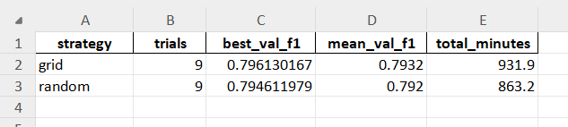
Fig 9. Summary

conclusion
This study successfully explored how automated hyperparameter optimization can improve the fine-tuning of Transformer-based models for Taglish sentiment analysis using the FiReCS dataset. The experiment used two main optimization methods—Grid Search and Random Search—to compare how each one performed in terms of accuracy, F1-score, and training time. By automating the tuning process through the Optuna framework, the notebook was able to test multiple combinations of hyperparameters such as learning rate, batch size, warm-up steps, and weight decay without manual adjustments. The results confirmed that both optimization strategies produced high and consistent performance while revealing clear differences in their efficiency.
Throughout the process, the FiReCS dataset proved to be a strong foundation for testing because it reflected the natural writing style of Filipino online users who often mix English and Tagalog words. The data preparation steps—including cleaning, tokenization, and splitting—ensured that the model learned from well-structured and balanced examples. The experiment began with a simple TF-IDF and Logistic Regression baseline to establish a performance reference, followed by fine-tuning of advanced models such as XLM-RoBERTa, ClinicalBERT, and DistilBERT. Each model was trained using the same evaluation settings, with automatic validation after every epoch and early stopping to prevent overfitting. These steps created a fair testing environment where the effect of optimization strategies could be measured accurately.
The results showed that both Grid Search and Random Search achieved nearly identical macro-F1 scores—around 0.79 to 0.80—but differed in how much time they required. Random Search completed trials faster while maintaining the same level of accuracy, making it the more practical choice for experiments conducted on limited resources such as Google Colab. Grid Search, on the other hand, offered a more complete overview of how each hyperparameter influenced model performance, though it took longer to finish. The comparison highlighted that while both approaches were effective, Random Search was more efficient and suitable for real-world applications where time and GPU usage are limited.
In conclusion, the experiment demonstrated that automated hyperparameter optimization using Optuna is an effective way to improve model tuning for multilingual and code-switched data like Taglish. It removed the need for manual trial-and-error adjustments, made the process faster, and still achieved strong results. The findings also showed that stable datasets such as FiReCS allow models to perform well across a wide range of parameter settings. This means that researchers and students can achieve good performance even with simpler optimization methods like Random Search. Overall, this work contributed to building a practical and repeatable process for training Transformer models efficiently while supporting the advancement of Taglish natural language processing research.

References

- C. J. Cosme and M. M. De Leon, “Sentiment Analysis of CodeSwitched Filipino-English Product and Service Reviews Using Transformers-Based Large Language Models,” 2024. Available: Archīum Ateneo.
- M. Herrera, A. Aich, and N. Parde, “A Dataset for Investigating Tagalog-English Code-Switching,” in Proc. LREC, 2022.
- H. Paul, R. Bansal, and M. Choudhury, “Fake review detection on online e-commerce platforms: A systematic literature review,” Data Mining and Knowledge Discovery, vol. 35, no. 6, pp. 2168–2211, 2021.
- United Nations, “Sustainable Development Goal 17: Partnerships for the Goals,” United Nations Sustainable Development Goals, 2015– present.
- S. Verhulst and A. Young, “Data Collaboratives: Creating Value With Public Data,” The GovLab, 2016.
- R. Vinuesa, H. Azizpour, I. Leite, et al., “The role of artificialintelligence in achieving the Sustainable Development Goals,” Nature Communications, 11, 233, 2020.
- A. Dey, D. Patra, S. Saha, and S. K. Ghosh, “Aspect-based sentiment analysis of consumer reviews,” Applied Soft Computing, vol. 155, 112259, 2024.
- A. Conneau et al., “Unsupervised Cross-lingual Representation Learning at Scale,” in Proc. ACL, 2020.
- DOST-ASTI, “RoBERTa-tl-sentiment-analysis,” Model Card, 2024. Available: Hugging Face.
- Associated Press, “The internet is rife with fake reviews. Will AI make it worse?,” Dec. 23, 2024.
- P. Quoc-Hung, L. Thi-Thanh-Hien, and N. Thanh-Tam, “Aspect-Based Sentiment Analysis of Clothing Reviews in E-Commerce,” in Proc. PACLIC, 2024.
- Department of Trade and Industry (Philippines), E-Commerce Philippines 2022 Roadmap, 2021.
- U.S. Department of Commerce, “Philippines – eCommerce,” Country Commercial Guide, Jan. 24, 2024.
- Google, Temasek, and Bain & Company, e-Conomy SEA 2024 report, 2024.
- C. J. Cosme, “FiReCS: Filipino–English Code-Switched Reviews Dataset,” Hugging Face, 2024. [Online]
- A. Alsentzer, J. Murphy, W. Boag et al., “Publicly Available Clinical BERT Embeddings for Clinical NLP,” Proc. Clinical NLP Workshop, 2019.
- V. Sanh, L. Debut, J. Chaumond, and T. Wolf, “DistilBERT, a Distilled Version of BERT: Smaller, Faster, Cheaper and Lighter,” arXiv preprint arXiv:1910.01108, 2019.
- T. Wolf et al., “Transformers: State-of-the-Art Natural Language Processing,” Proc. EMNLP: System Demonstrations, 2020.

